**General Chemistry LabII-1112L**

# Lab Report#___4___

Andrew Kalathra, Department of Chemistry and Biochemistry, Lamar University, Beaumont TX 77710

**Title- Intermolecular Forces**

**Objective**- Find how intermolecular forces affect observable behaviors of substances.

**Procedure-** 1. To begin, we got and set up our equipment. This includes setting up the heat probe and connecting it to the device, getting 5 test tubes, a ring stand, a rubber band, and 5mL of each chemical: methanol, ethanol, 1-propane, 1-butane, and acetone.

2. Secondly, we wrapped a piece of paper towel around the probe, secured it with a rubber band, and let it sit in our first solution, methanol, for 30 seconds.

3. After the 30 seconds, we started the device to record the temperature change. After 15 second of the probe still in the solution, we removed it and left it on the ring stand till the temperature stopped falling, or just started rising.

4. We then repeated these steps for each of the chemicals and copied down the results of the highest and lowest temperatures reached for each solution.

**Data and Results** 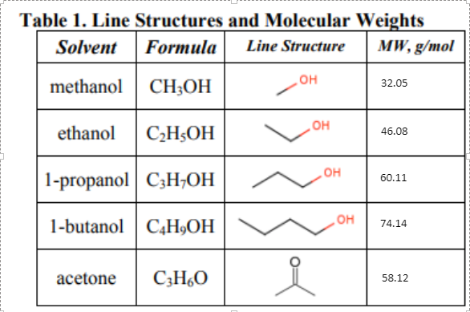

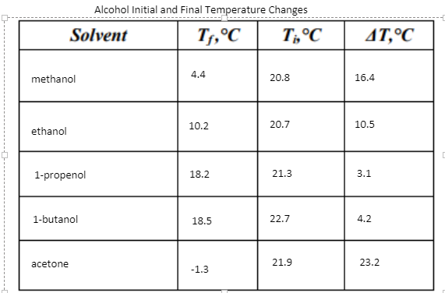

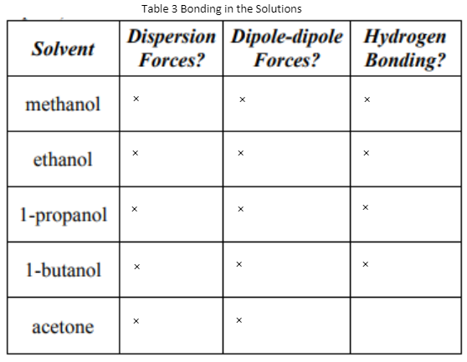

Solutions with hydrogen bonds usually have higher imf’s, meaning that there is a lower change in temperature. Secondly, the bigger the mass of the solution, the bigger the imf’s, the lower the change in temperature. This is because the bigger the molecules, the better chance of them forming induced dipoles, which is the basis of London dispersion forces.

**Conclusions**

In conclusion, though the intermolecular forces we observed are relatively weak, they can change physical properties we observe. The strongest intermolecular force we observed (or that made a big difference) is the hydrogen bonds. The next biggest was dipole-dipole, though all molecules had them. And finally, the least but still relevant force was the London dispersion force. The dipole-dipole and London dispersion forces both relied on properties of the solution. For example, the dipole-dipole was a stronger force in the molecules of less C-H bonds, because they were not polar. The London dispersion force was stronger as the mass increased. These imf changed the phisical property we observed: Hvap ,or heat of vaporization. As the imf’s increased in strength, there would be a lower change in temperature as the solutions changed from liquid to gas. We achieved observing and learning about imf’s by observing very similar chemical compounds differ in the same test.

**Key Questions- Answer** all key questions in your lab manual and place them here.

1. What is evaporation? - A change in phase from a liquid to a gas.

2. Why do some substances evaporate at a faster rate than others at the same temperature? - Some take less energy to change phases from liquid to gas compared to other substances.

3. Why is evaporation considered to be an endothermic process? - An endothermic process is a process that extracts heat from the system. Evaporation usually needs energy to change the phase of the substance, and that energy if usually heat from the surroundings

4. For the following substances, find the molecular weight and record it in Table 1. The line structures may be omitted from the notebook – Table 1 above

5. Based on the personal experience of your team's members, which provides a greater sensation of cooling when it evaporates from the skin water (TBP = 100 ºC) or rubbing alcohol (TBP = 82 ºC)? Based on the boiling points which has the weaker intermolecular attractions? - Rubbing alcohol for both

6. Which molecule in the table above should have the strongest interactions with like molecules, producing the least cooling of the five? - 1 propenol

7. Based on line structures and molecular weights in Table 1, which molecule in the table above should have the weakest interactions with like molecules, producing the most cooling of the five? Why? - Acetone, because it has no h bonds, though 1-butenol had a low dipole interaction due to the amount of CH bonds.

8. Did the results support the hypotheses your team made in Questions 5 and 6? If your team's hypotheses differed from the observations, how did they differ? - We got them correct.

9. Which solvent showed the strongest intermolecular interactions? Which showed the least?- 1-propenol, acetone

10. What is the main difference in a polar molecule and a nonpolar molecule? - one has partial charges, the oher does not, due to one pulling the electrons more

11. What are the restrictions on which molecules can hydrogen bond? - F, O, and N, they are very electronegative

12. Which of the solvents used in this laboratory can exhibit hydrogen bonding? Why? - methanol, ethanol, 1-propanol, and 1-butenol all exhibit h bonding due to the O-H in each.

13. Which of the solvents used in this laboratory can exhibit dipole-dipole intermolecular force interactions? Why? - They all exhibit dipole dipole interactions because they all have some molecules that are more electronegative than others.

14. Which of the solvents used in the laboratory have London dispersion forces as their only intermolecular interaction?- none

15. Which solvents can have both hydrogen bonding and London dispersion forces? - methanol, ethanol, 1-propanol, and 1-butenol

16. Which solvents can have both dipole-dipole and London dispersion forces? - all

17. Why should the solvents with the stronger interactions have smaller magnitude ΔT values as the solvent evaporates? - Alcohols act differently than other molecules due to their OH group, so normal solutions would have a greater change in temperature, ΔT, proportional to their imf’s, but alcohols do the opposite.

18. Why do the two of the solvents, acetone and 1- propanol, which have nearly the same molecular weights, have significantly different ΔT values? - 1-propanol contains h-bonds which are very strong

19. What affect does the molecular weight have on the strength of intermolecular interactions?- Usually, the heavier the molecule, the bigger the molecule, which usually means bigger the chance of an instantaneous dipole. In short, : heavier = bigger = bigger London dispersion = bigger IMF’s

20. Besides evaporation, what is another physical property dependent on the interactions between individual molecules? Explain why your team chose this property. - Boiling and freezing points, they can show the change in temperature.

21. In Table 3, for each of the solvents used in this lab, indicate which intermolecular forces each should exhibit. - Table 3 above

* Do not forget to attach the signed lab work-out

